5.2 E Assessing regional seed flows (i.e. where seed might come from)

Quick version (focus on informal, local channels)
For some key crops and varieties, grain which can be planted as seed can be obtained from local markets. But not all grain sold in local markets is suitable for planting. One of the major aspects determining if grain can be planted is whether the variety (ies) is adapted to local agro-ecological conditions (soil type, rainfall needs, elevation). To describe grain which can be planted (versus that which never be sown), we use the term ‘potential seed’.

Interviews with local agronomists, traders and farmer-buyers can shed light on the issue of which agro-ecological zones in a region normally supply potential seed (i.e. adapted varieties) to the local markets. Remember that the assessment has to go crop by crop as zones of adaptation different greatly by crop type. In mapping the regional seed flows, you are trying to determine whether the zones that provided grain for use as seed prior to the instability are still open in the current period (Here we focus mainly on the issue of adaptation).

We give an example below of how mapping grain/seed flows from specific agroecological zones to markets can be important for understanding potential seed supplies available to farmers. Western Haraghe is a drought-prone zone is northern Ethiopia – and might be comparable to a target zone in a disaster. Here—in the region of West Haraghe—the major crop, sorghum has very local adaptation and grain that will be planted (that is, potential seed) needs to be obtained locally (ellipse A), or at least from an area of similar elevation (with 10km). Crops like maize, with intermediate adaptation, may be sourced from farther afield (ellipse B). Improved varieties of common bean may be widely adapted to conditions in a much larger area (ellipse C), with seed often obtained from large producers even 200 kilometers away. ( Note, in some cases, seed may also cross international borders).

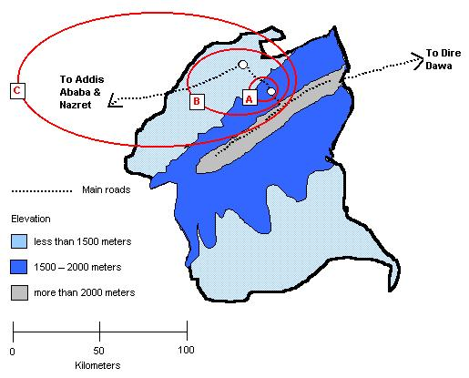

Now take the three major food security crops in your target zone of action. Map the areas in the region where potential seed is normally sourced by traders . (Talk to traders, agronomists, farmer-buyers). Are these sources areas still potentially open to provide stocks? Also, it is very useful to bring an existing regional map with you, so those interviewed can point to specific places and trace trading routes.)

Crop 1______

For crop 1, map below areas in the region where traders source grain that can be planted, used for seed | Are these regional routes still open?  Yes/no. explain  (e.g. routes remain officially closed but cross border trade still occurring)  Can these regions still supply potential seed? (was the harvest in the area good? Was the quality of the harvest acceptable to farmers? ) explain  (e.g. drought has reduced quantities of potential seed in preferred agro-ecological zones).

Repeat the procedure for each major crop. Flows might vary, crop by crop

