1.1 E Seed System Security Assessment 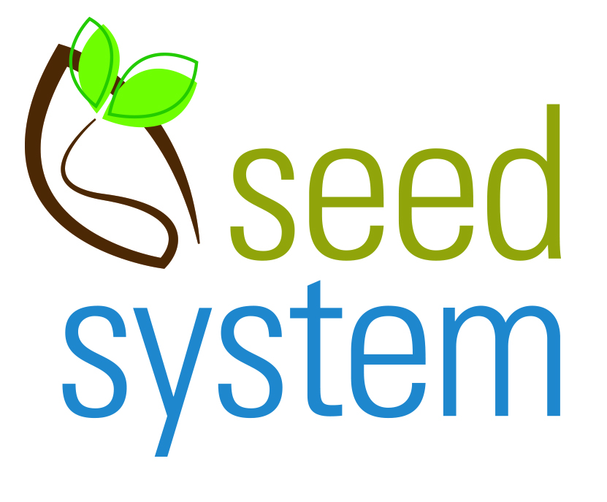
Preparatory work: Plant Breeding and Varieties (6/24/2024)

Overview Theme: Plant Breeding and Variety Release

The work will help stakeholders understand the background for variety development, variety release, and varieties available to farmers in each of the SSSA zones. Include insights from the private sector as well and public sector.

Task 1: Review current breeding structures and processes (reflect particularly on changes of the last 20 years)

Task 2: Make a list of crops and varieties released for each SSSA zone and describe their key features (e.g. drought tolerant)

Review current breeding structures and processes

1a Describe the current structures by which plant breeding takes place in-country and reflect on trends and changes in the last 20 years.

1b Describe and assess other ways by which new varieties are being introduced (deriving from research and development outside the country—public and private) (be specific: by crop, describe processes and actors)

2.a Examine and elaborate (if needed) the existing variety list by all crops, of:
- varieties released
- dates of release
- zones of adaptation If known. (If not known, describe desired process for obtaining adaptation information)
- any other information- linked to variety on specific trait

2.b Give specific details of the ‘most preferred varieties by crop, including which varieties are being adopted by farmers—and with what evidence

2.c Reflect on the role of local varieties in boosting and stabilizing agricultural production -- and on the process for identifying the ‘best bets’

